EDUGENIE – Google Gemini Powered Learning Assistant

TEAM MEMBERS:
- Kanisha P(Team Leader) - kanisha.p.25ds020@gmail.com
- Janavikaa G.J- janavikaa.g.j.25ds018@gmail.com
- Sathana S- sathana.s25ds039@gmail.com
- Suvitha S- suvitha.s.25ds044@gmail.com

PROJECT OVERVIEW:
EduGenie is an AI-powered assistant created to help students at different points in their learning journey. The app brings learning tools together in one online platform.
The system lets users ask questions get explanations of ideas make quizzes shorten long text and get organized learning suggestions.
The backend of EduGenie is built with FastAPI and the web interface of EduGenie is made with HTML and CSS. The current implementation of EduGenie uses Gemini 3.5 Flash, for cloud-based AI operations and the current implementation of EduGenie also uses LaMini-Flan-T5-783M for concept explanation. The major functions of the application are:
- Question Answering
- Concept Explanation
- Quiz Generation
- Text Summarization
- Learning Path Generation
- The application follows a modular structure so that each major function is implemented separately and connected through the backend.
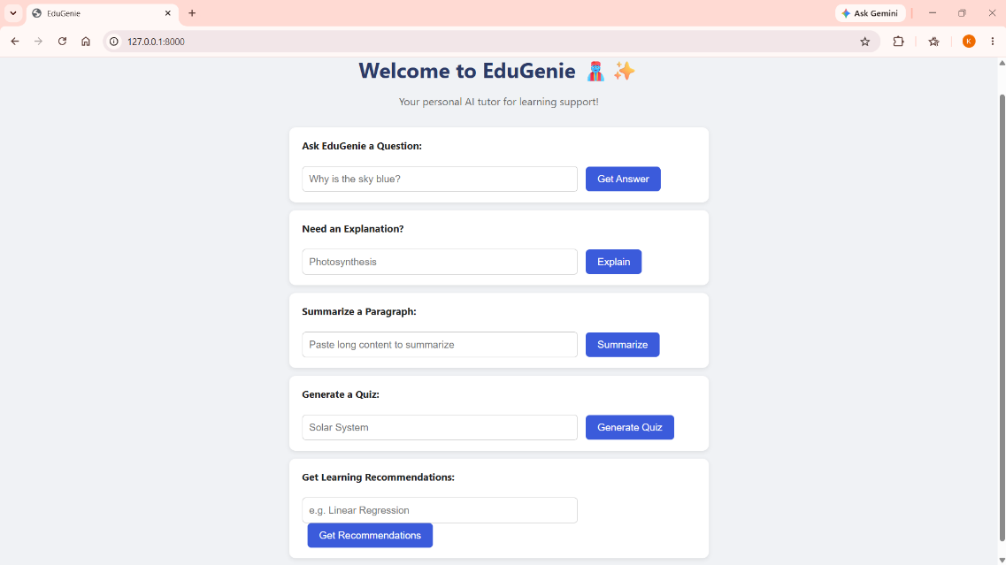

Figure 1: EduGenie Main User Interface

PROJECT OBJECTIVES:
The primary goal of EduGenie is to create an intelligent learning assistant that will be able to offer several kinds of academic assistance to the students via one program.
Objectives of the project include the following:
1.Providing fast solutions to academic questions.
2.Simplification of complex ideas for the learner.
3.Creation of quizzes to assess the level of knowledge.
4.Summarization of extensive educational materials.
5.Creating learning paths for certain subjects.
6.Integration of the generative AI in an educational website.
7.Facilitating an easy learning interface for the user.
8.Breaking down the different learning functions based on AI into different modules.

APPLICATION SCENARIOS:

1.Academic Question Answering:
EduGenie can be used by the students if they are in confusion regarding some subject matter.
They can enter the question in the Q&A area, and then it processes the input via Gemini model.
The result will be shown on the interface.

2.Understanding Complex Concepts:
Some complex concepts related to academics and technical subjects may pose difficulties for the newbies.
There is an explanation feature provided by EduGenie, which produces a simple explanation of some topics.
Algorithm, computer concepts, and other academic subjects can be input in the explanation area.

3.Self Assessment Using Quizzes:
Quizzes can be used by learners after learning a particular topic.
Questions in the form of multiple choices are created using the supplied material. The users will be able to choose their answers.

4.Revision Made Easy Using Summaries:
Large amount of educational material is not easy to revise.
Using the summarization feature, the large amount of material is reduced to short summaries that contain the main points.
This can serve as a revision tool prior to examination.

5.Guided Learning:
The learner might be aware of the topic he/she wishes to learn but may not be aware of the proper sequence of learning.
The learning path tool will present the learners with a progressive set of topics from the basics to the advanced topics.

ARCHITECTURE OF THE SYSTEM:
EduGenie is designed with a modular client-server architecture.
The user operates the frontend module, and the backend component that connects the interface with the different AI components is FastAPI.
The basic process flow is:
Gemini 3.5 Flash is used for the cloud-based generative AI functions, while LaMini-Flan-T5-783M is used locally for concept explanation.
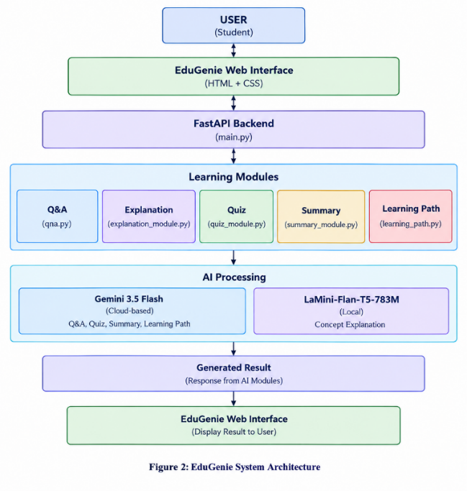
Figure 2: EduGenie System Architecture

SOFTWARE AND HARDWARE REQUIREMENTS:

Software Requirements:
The main software components required for EduGenie are:
- Python
- FastAPI
- Uvicorn
- Google Gemini API
- Google Generative AI Python package
- Transformers
- PyTorch
- SentencePiece
- Accelerate
- Jinja2
- Python-dotenv
- HTML
- CSS
- Visual Studio Code
- Web browser

Hardware Requirements:
- An EduGenie computer should be able to run Python, the FastAPI server, and the local language model.
- Stable internet connectivity is necessary for API-based functionality from Gemini API.
- Memory and processing power of the system need to be enough to support loading of the local LaMini-Flan-T5-783M model.

TECHNOLOGY STACK:

1 Python:
Python is employed as the main programming language for the backend and AI modules.

2 FastAPI:
FastAPI is the backend framework of EduGenie.
It gets requests from the frontend, processes the request via the suitable module, and sends back the output.

3 Gemini 3.5 Flash:
Gemini 3.5 Flash is the cloud-based AI model which is used in the latest version of EduGenie.
It is used to:
- Generate questions and answers
- Create quizzes
- Perform text summarization
- Generate learning paths
The model is accessed via the Gemini API.

4 LaMini-Flan-T5-783M:
LaMini-Flan-T5-783M is used locally to generate explanations in a simple way.
The model receives the selected topic and the instruction to explain it in a simplified way.

5 HTML and CSS:
HTML is used to define the structure of the web interface, while CSS is used to define the visual aspect of the web interface.

6 Jinja2:
Jinja2 is used to render the HTML template via the FastAPI app.

7 Uvicorn:
Uvicorn is used as the local server for the FastAPI app.

AI MODEL SETUP:
EduGenie employs two AI models, where each model has its own task to perform.

1 Gemini 3.5 Flash:
The Gemini model has been linked via Gemini API.
It performs all text generation tasks in the cloud that are needed by the application.
The Gemini model has the following modules:
- Question answering
- Quiz generation
- Text summarization
- Learning path generation
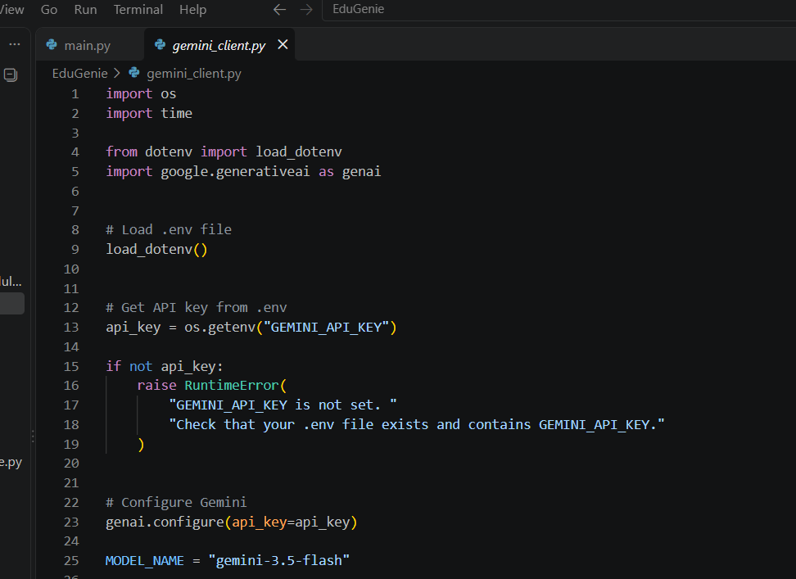
Figure 3: Gemini 3.5 Flash Configuration

2 LaMini-Flan-T5-783M:
The local model is used specifically for generating easy-to-understand explanations.
The model is loaded using the Transformers library and processes the topic locally.
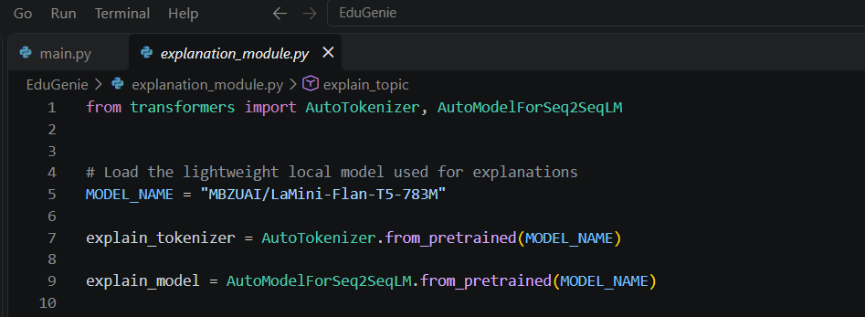
Figure 4: LaMini-Flan-T5-783M Model Implementation

PROJECT STRUCTURE:
The EduGenie project is organized into separate modules according to their responsibilities.
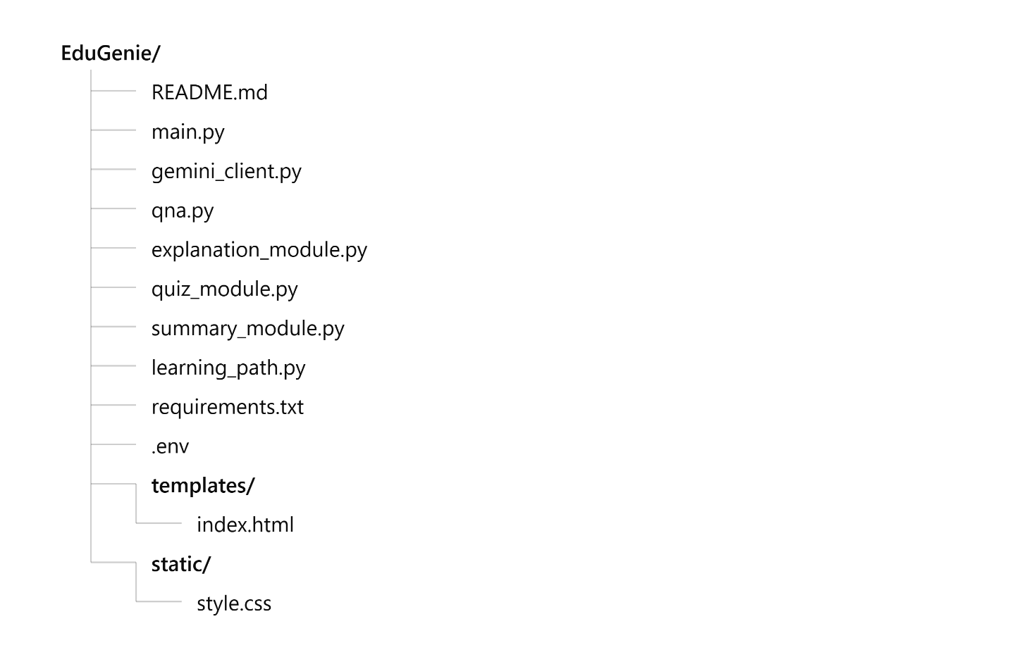

1 main.py:
Contains the main FastAPI application and API routes.

2 gemini_client.py:
Handles Gemini configuration and communication with the Gemini API.

3 qna.py:
Contains the question-answering functionality.

4 explanation_module.py:
Implements concept explanation using the local language model.

5 quiz_module.py:
Generates multiple-choice quizzes.

6 summary_module.py:
Processes supplied text and generates summaries.

7 learning_path.py:
Creates structured learning recommendations.

8 templates/index.html:
Contains the structure of the EduGenie webpage.

9 static/style.css:
Contains the visual styling of the application.

10 requirements.txt:
Lists the Python packages required by the project.

11 .env:
Stores environment configuration such as the Gemini API key.

12 README.md:
Contains the project documentation, including the project description, features, technologies used, project structure, installation steps, execution instructions, API endpoints, AI model details, and future enhancements.
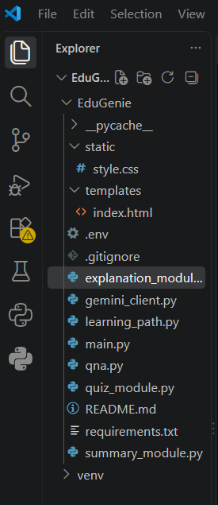
Figure 5: EduGenie Project Structure

CORE FUNCTIONAL MODULES:

1 Question Answering Module:
Question Answering component enables users to ask natural language questions.
The request goes through the FastAPI backend and reaches the Q&A component. The Q&A component utilizes Gemini 3.5 Flash for answering questions.
The general process is:

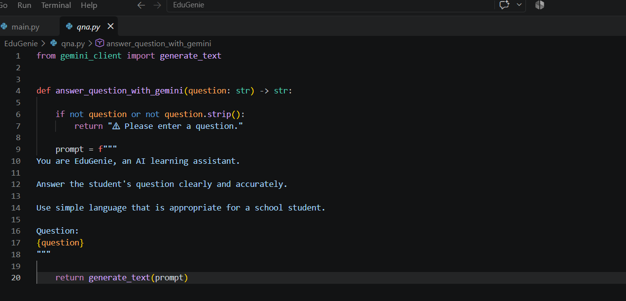
Figure 6: Question Answering Module Implementation

2 Concept Explanation Module:
The Module Concept Explanation is created in order to simplify complicated subjects.
The user inputs a subject, which gets transformed into an instructional prompt.
This prompt is then processed with LaMini-Flan-T5-783M and the generated explanation is provided to the app.
The process chain is:

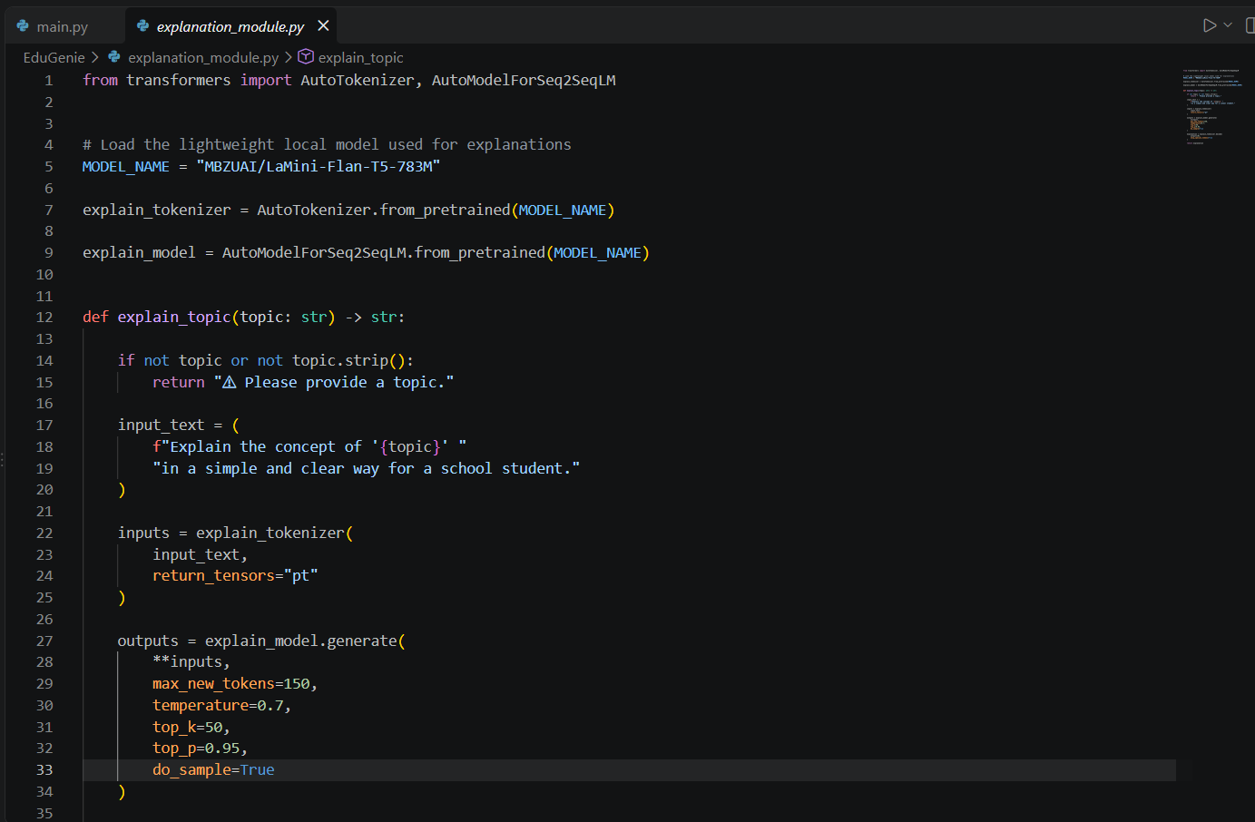
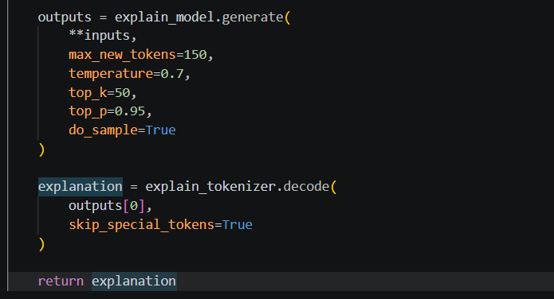
Figure 7: Concept Explanation Module Implementation

3 Quiz Generation Module:
The Quiz component generates multiple choice quizzes based on the supplied learning materials.
The input is fed into Gemini 3.5 Flash and is asked to create a quiz out of it.
The output received from the generator is processed in the backend for display in the web front-end.
The general workflow is:

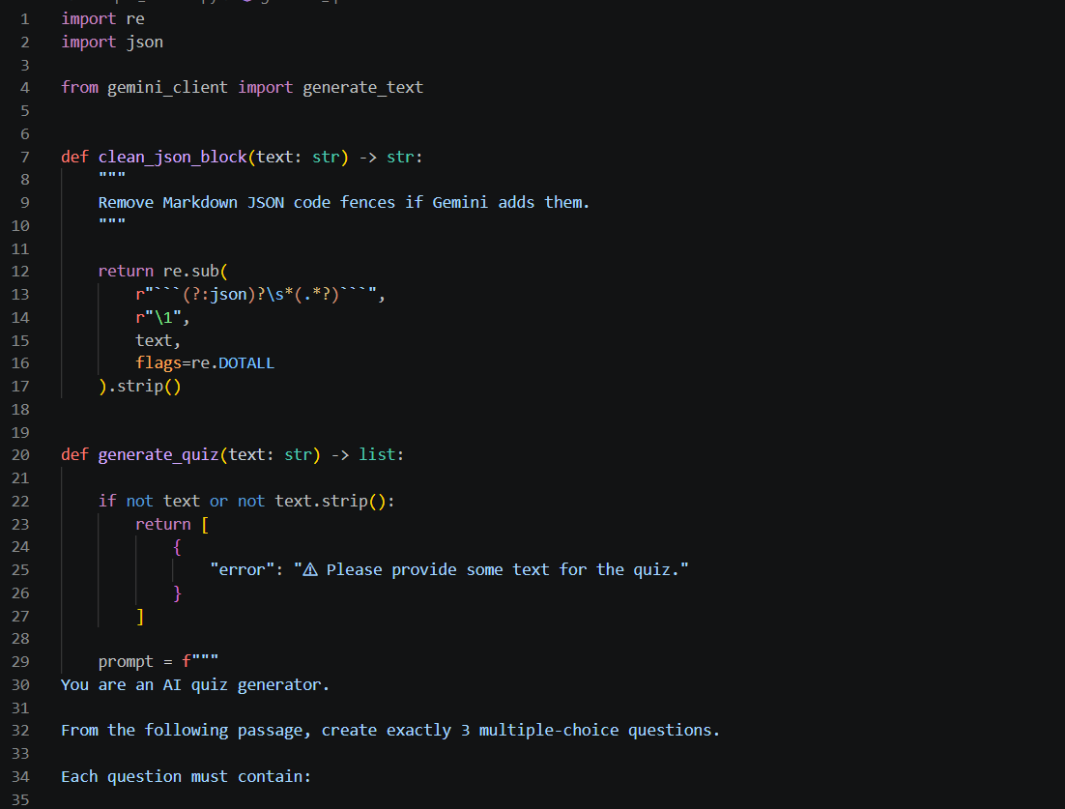
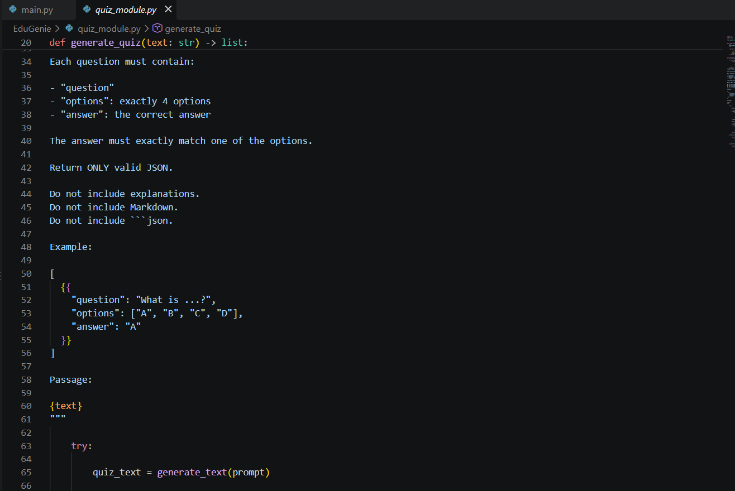
Figure 8: Quiz Generation Module Implementation

4 Text Summarization Module:
The Text Summarization module condenses the long text into a brief one.
The input text is passed to Gemini 3.5 Flash for summarization with instructions to keep the crucial details while reducing its length.
The workflow is:

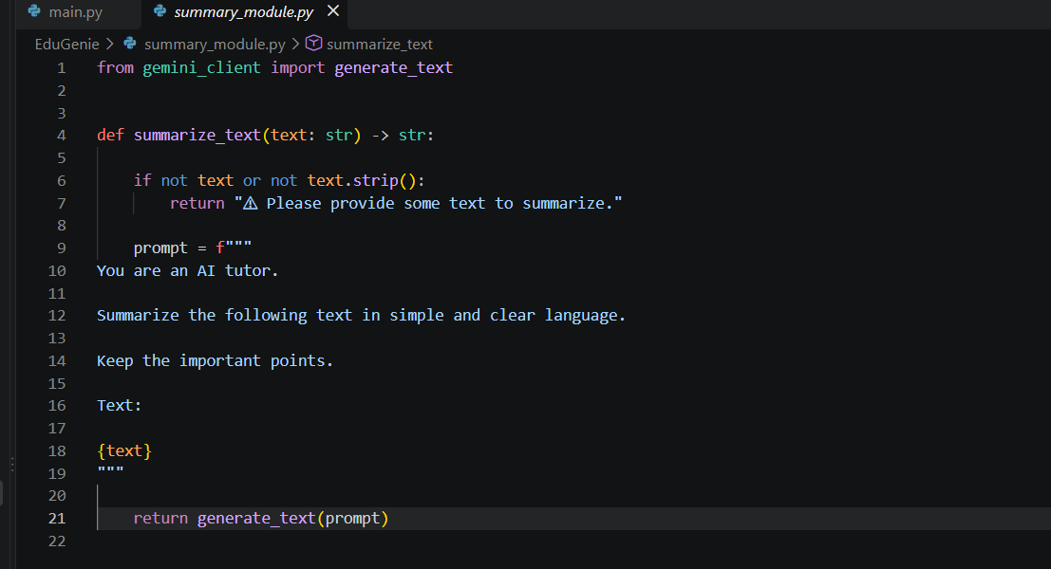
Figure 9: Text Summarization Module Implementation

5 Learning Path Module:
The learning path module creates an organized order of topics on a chosen subject.
The learner selects a topic, and then the module creates a path starting from basic knowledge and moving towards advanced knowledge.
The module will offer:
- Topic order
- Learning stages
- Duration
- Learning resources
- Learning practices
The processing flow is:

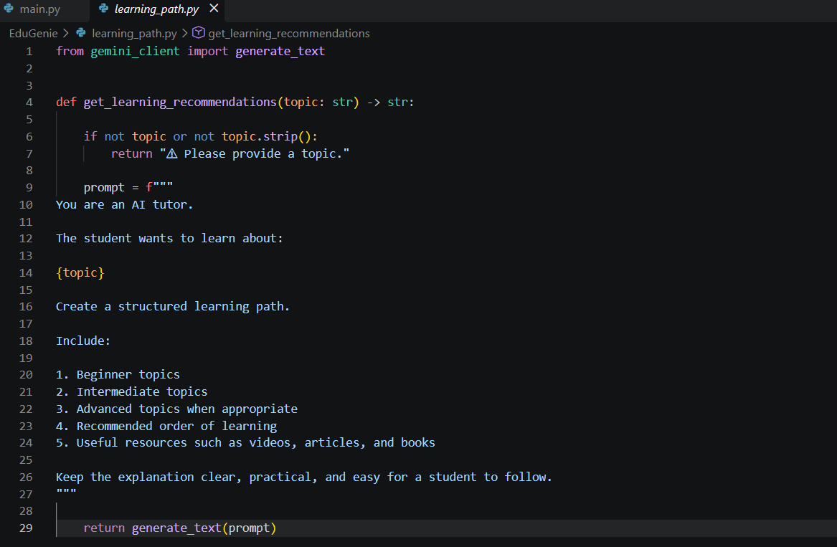
Figure 10: Learning Path Generation Implementation

FASTAPI BACKEND IMPLEMENTATION:
FastAPI acts as the central communication layer of EduGenie.
The application defines separate endpoints for each major functionality.
Endpoint | Purpose
/qa | Question Answering
/explain/ | Concept Explanation
/quiz | Quiz Generation
/summarize/ | Text Summarization
/learn/recommendations | Learning Path Generation
The backend receives the input, calls the relevant module, and returns the generated result.
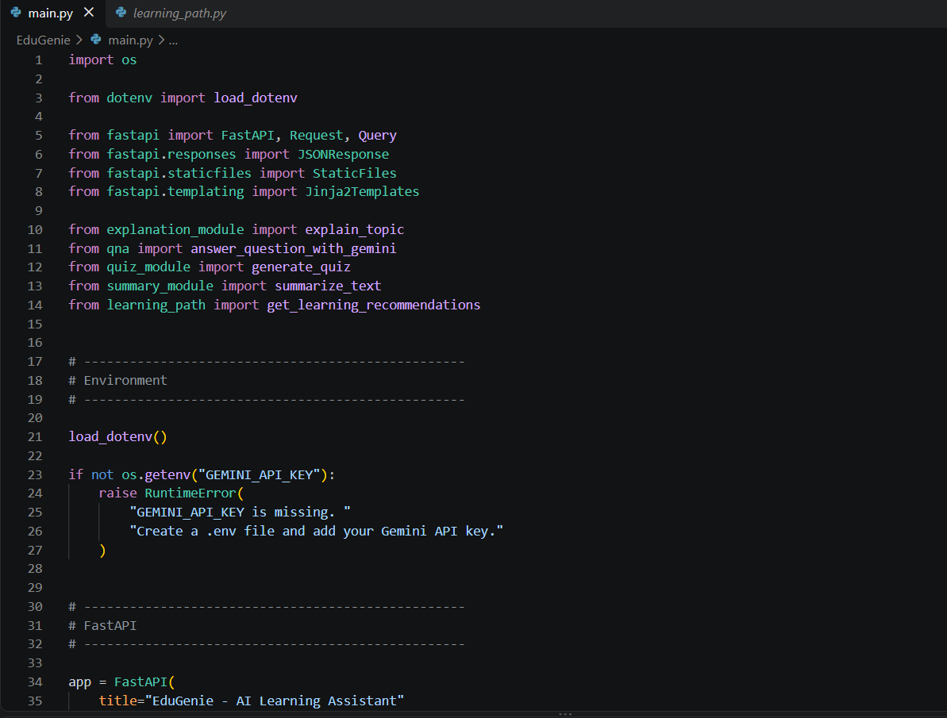
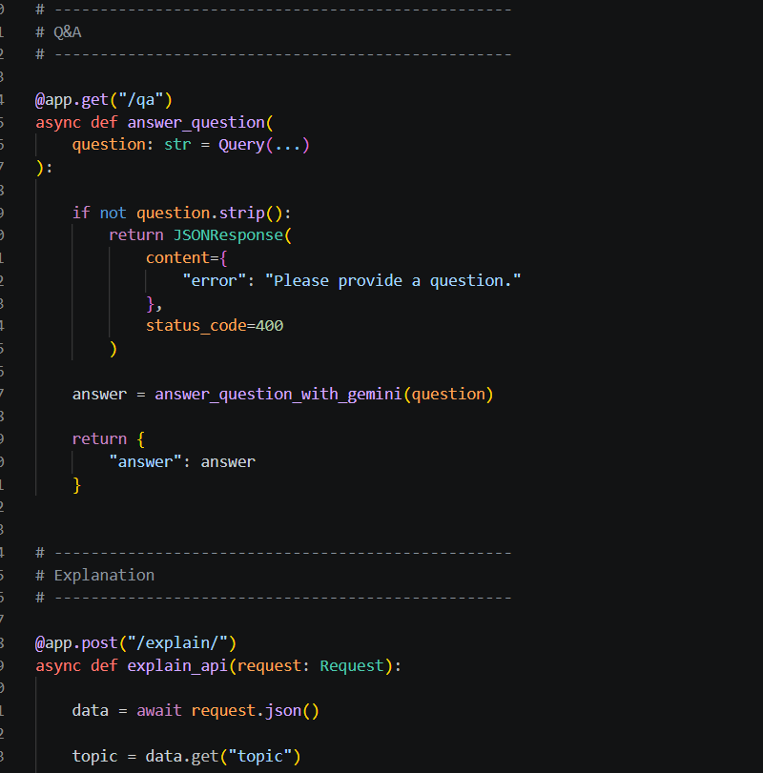
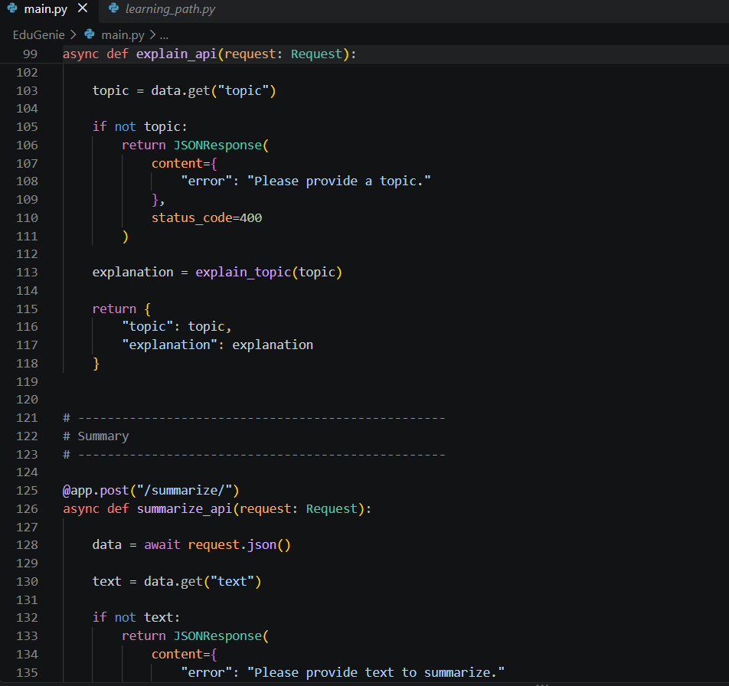
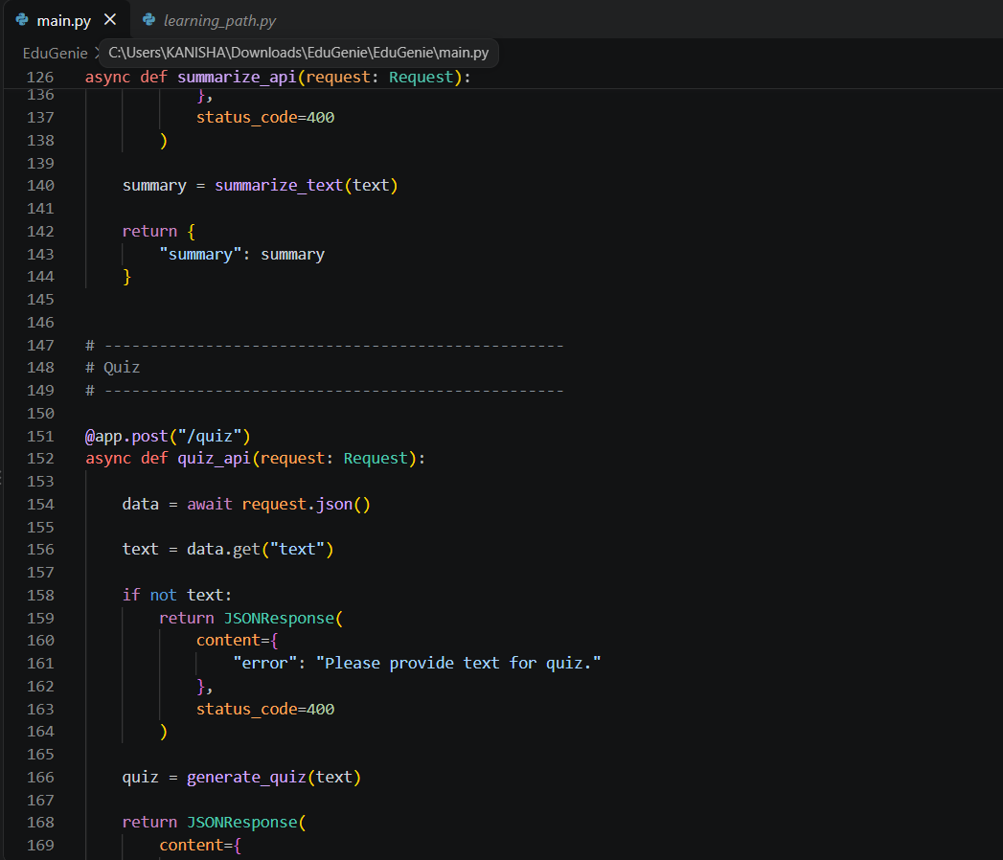
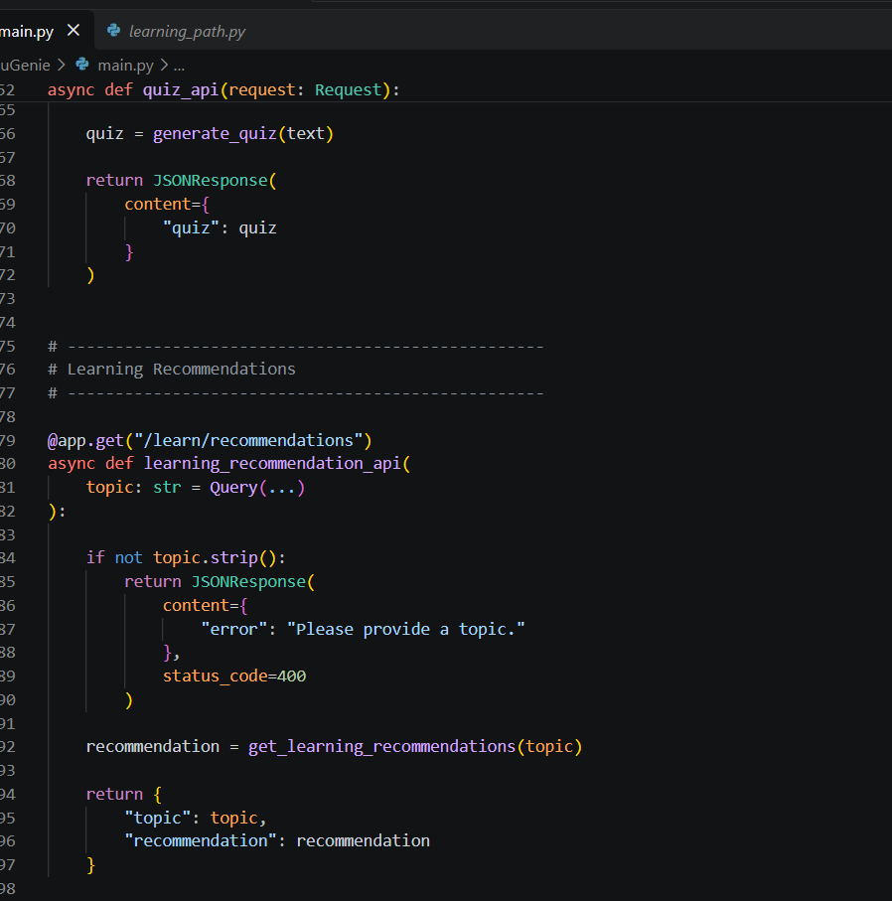
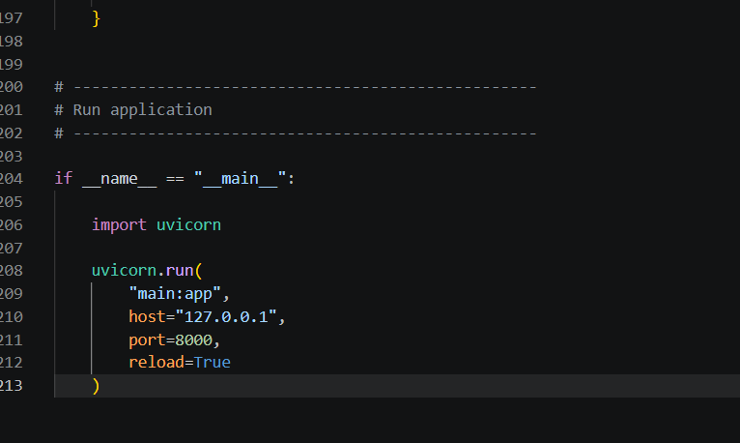
Figure 11: FastAPI Backend and API Route Implementation

USER INTERFACE DEVELOPMENT:
The frontend of EduGenie has been created to give users a straightforward interface where they can easily access the various AI capabilities.
This webpage offers users controls for the following:
- Explanation
- Q&A
- Quiz
- Summary
- Learning Path
The frontend always interacts with the FastAPI backend whenever a user submits a request.
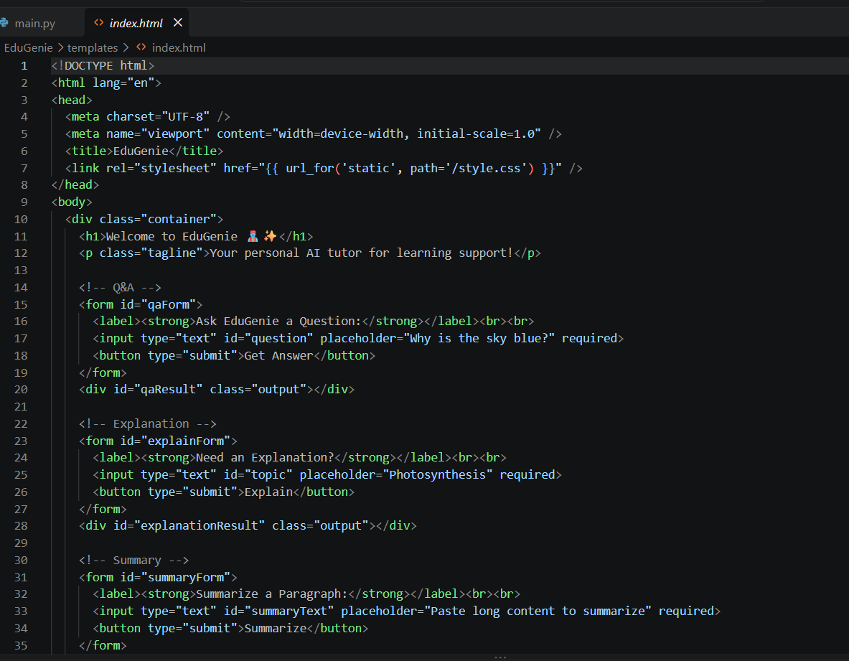
Figure 12: EduGenie Frontend Implementation

APPLICATION SETUP AND EXECUTION:

1 Creating a Python Virtual Environment:
This command is used to create a virtual environment:
python -m venv venv
After the creation of the environment, it must be activated before installing the dependencies for the project.
2 Installing Dependencies:
Dependencies will be installed using the command:
pip install -r requirements.txt
3 Configuring Gemini API Key:
Gemini API key is provided via environment variables.
The .env file has the following structure:
GEMINI_API_KEY=YOUR_API_KEY
The real API key must not be presented in the screenshots.
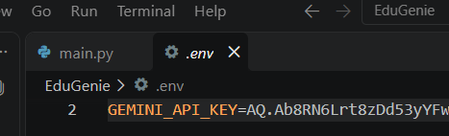
Figure 13: Environment Variable Configuration

4 Starting the Application:
The FastAPI application can be started using:
uvicorn main:app --reload
The application can then be accessed through:
http://127.0.0.1:8000
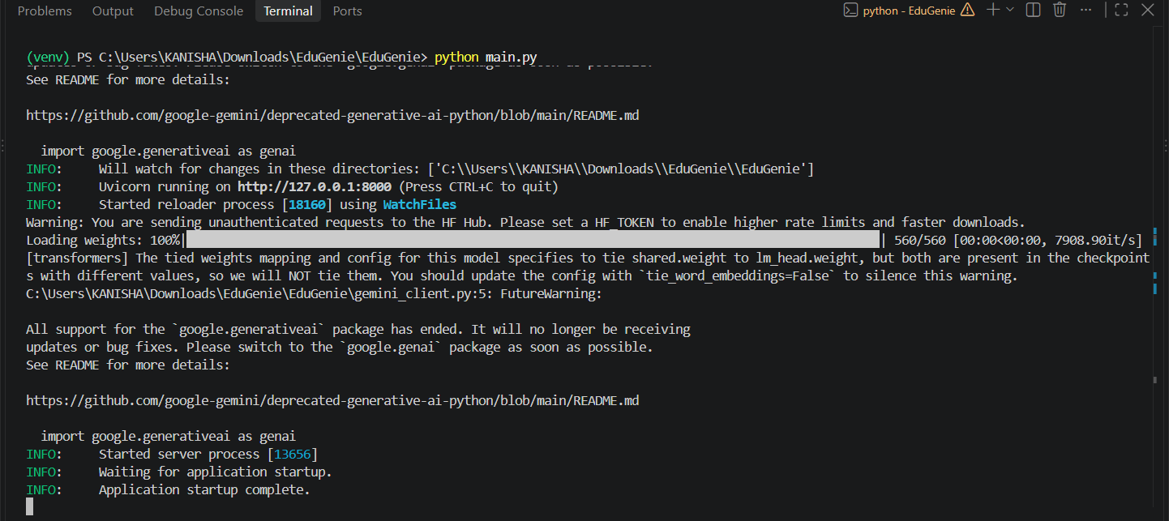
Figure 14: EduGenie Application Running on Local Server

FINAL OUTPUT SCREENS / RESULTS:
All major output screenshots are grouped in this section to show the completed functionality of EduGenie.

1 Main EduGenie Interface:

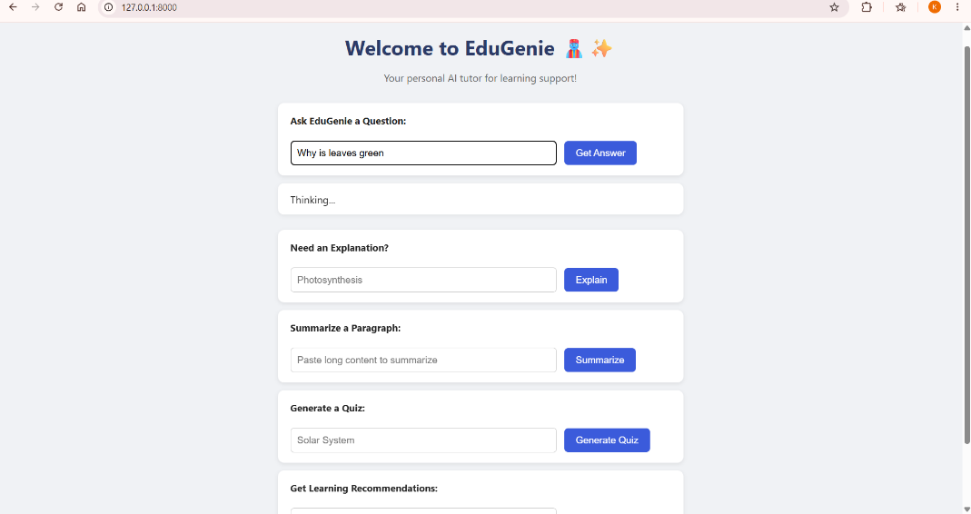

2 Question Answering Output
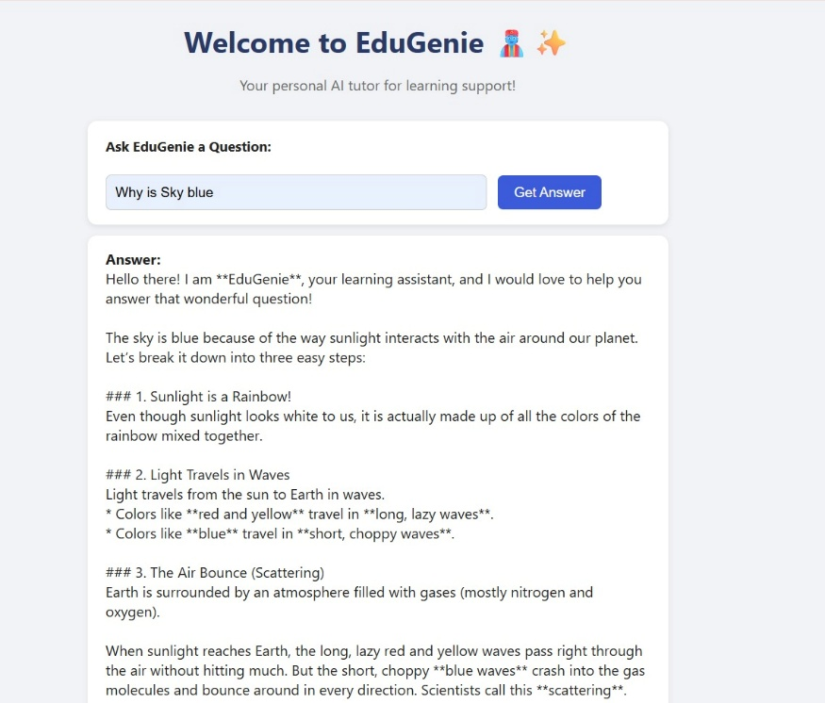
Figure 16: Question Answering Result

3 Concept Explanation Output

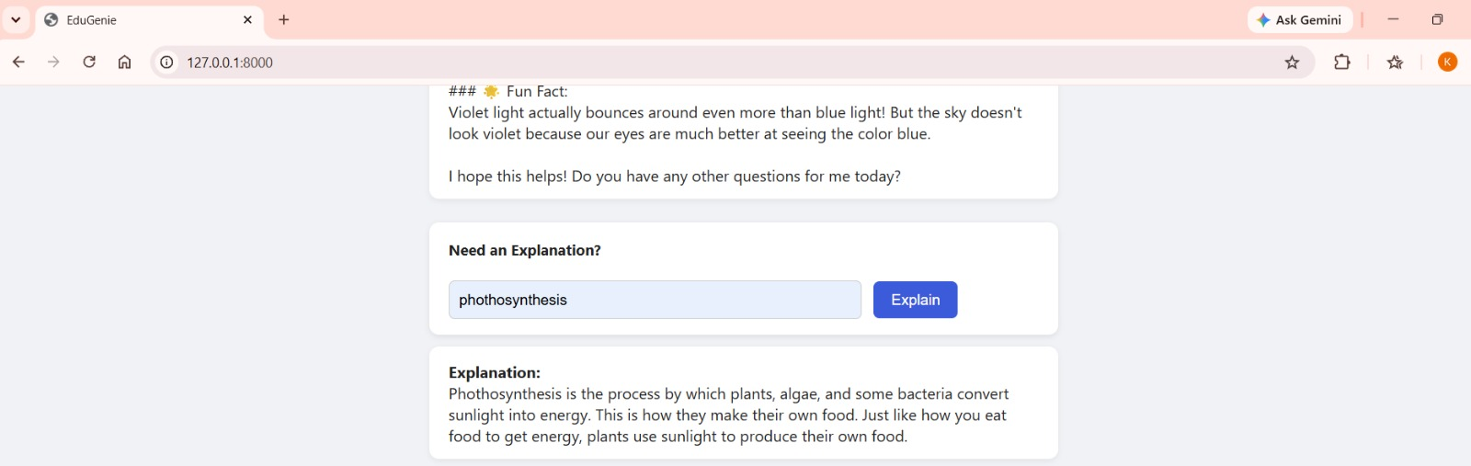
Figure 17: Concept Explanation Result

4 Quiz Generation Output
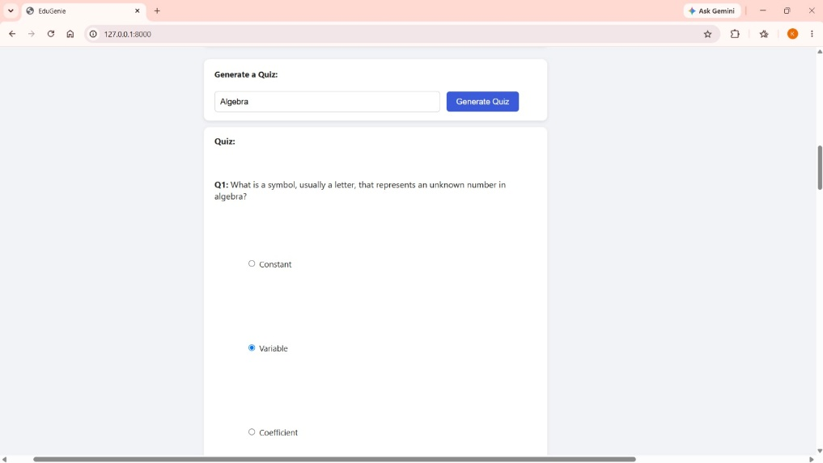
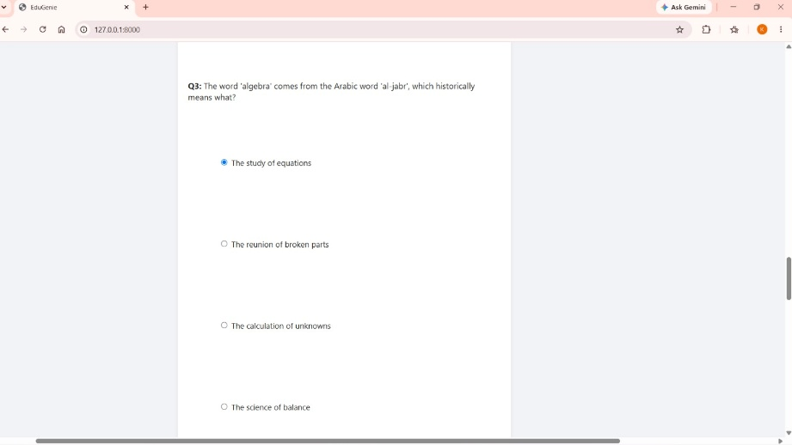
Figure 18: Generated Quiz Result

5 Text Summarization Output
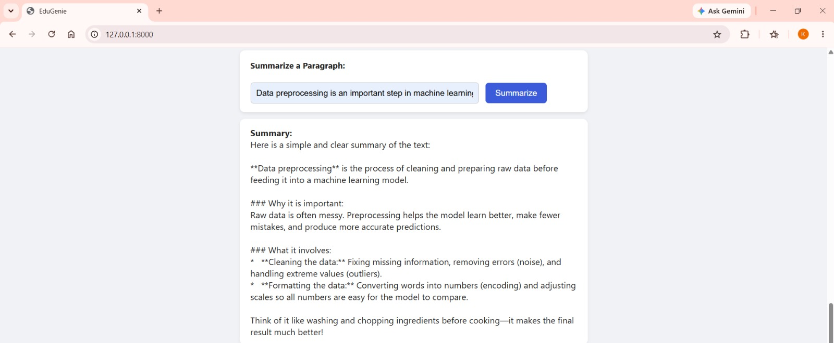

Figure 19: Text Summarization Result

6 Learning Path Output
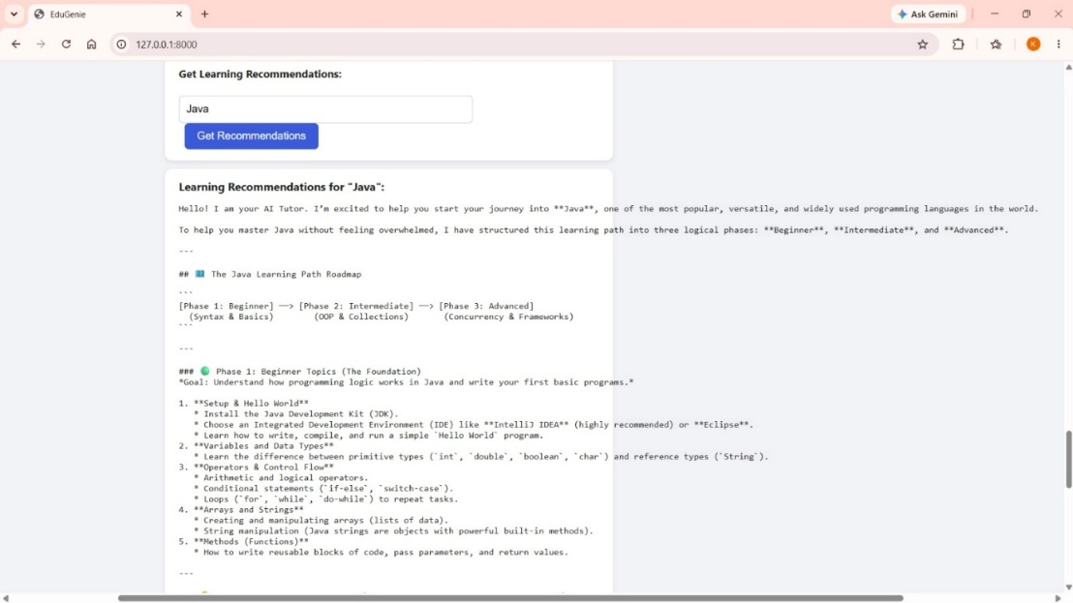
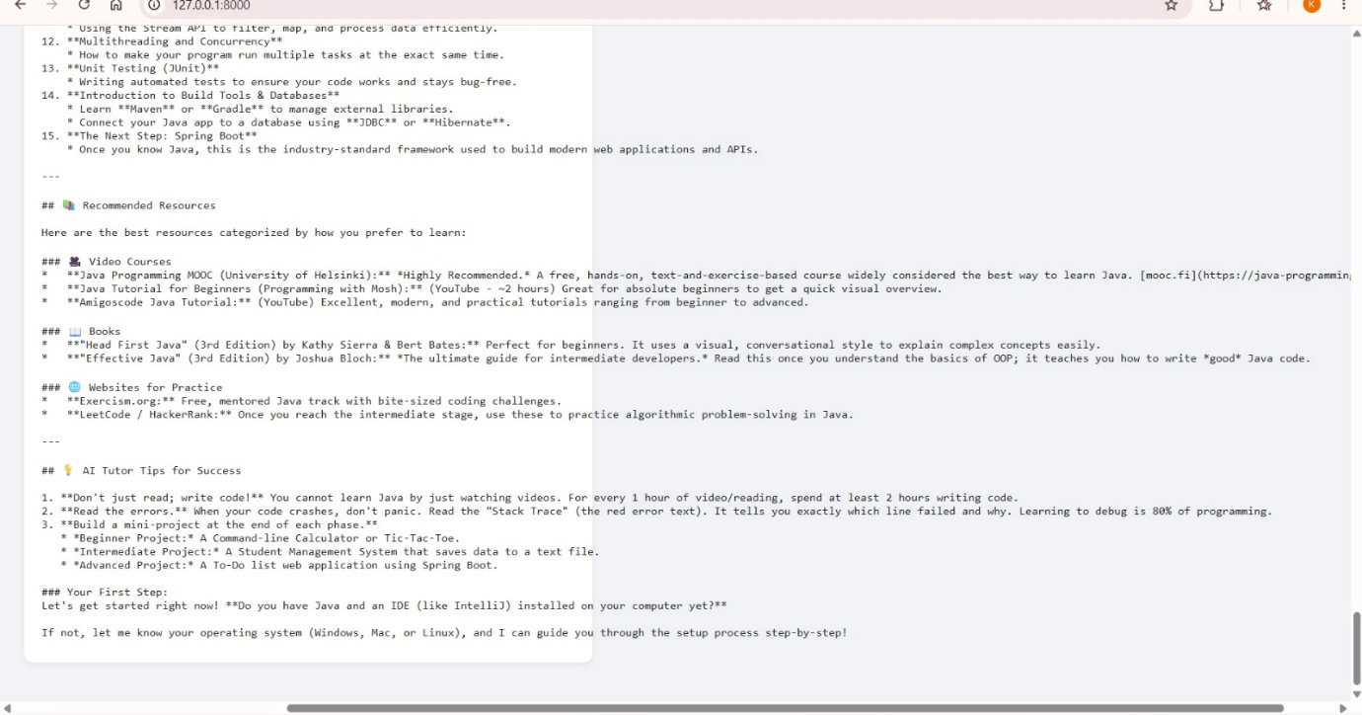
Figure 20: Generated Learning Path

FUTURE ENHANCEMENTS
There is potential for extending EduGenie with new capabilities in subsequent iterations.

1 Voice Interaction
Voice-based input and speech output can be implemented to enable voice-based interaction with the assistant.

2 Multilingual Learning
Multilanguage support could be implemented to enable explanations in different languages.

3 Mobile Application
A mobile application would make it possible for users to access EduGenie via smartphones and tablets.

4 Learning Progress Tracking
Learning progress tracking dashboard will allow tracking of topics covered, results in quizzes, study duration and other data.

5 Gamification
Badges, achievements, challenges, learning streaks and other gamification elements can be implemented to increase engagement.

6 Adaptive Learning
The system can make use of previous user's learning activity and quiz results to create personalized learning paths.

7 Group Learning
Group learning features will enable collaborative learning activities for several learners.

8 Teacher and Parent Dashboards
Extra dashboards will enable teachers and parents to track learners' progress.

9 LMS Integration
Integrations with other learning management systems can be implemented to work alongside other education software.

10 Image and PDF Processing
The system could be updated to process images and PDF files and provide answers based on those.

11 Notifications
Notifications can be introduced to encourage learners to stick to regular learning schedule.

CONCLUSION:
EduGenie is an intelligent web application which unites multiple educational features into one AI-based learning assistant.
These features include question answering, concept explanation, quiz creation, text summarization, and recommended structured learning.
FastAPI is used as a backend, whereas the frontend is created with the help of HTML and CSS technologies. Cloud-based generative AI technology is implemented by using Gemini 3.5 Flash, whereas LaMini-Flan-T5-783M is used locally for concept explanation.
This allows developing and maintaining the learning functions separately in a modular way with interaction via the FastAPI backend.
By integrating AI-generated answers, concept simplification, quizzes, summaries, and learning recommendations, EduGenie creates a basis for an intelligent digital learning assistant.
EduGenie can be extended with such features as voice interaction, multilinguality, mobile support, progress monitoring, adaptive learning, and document-based question answering.

Project Repository Link: https://github.com/kanisha-P25ds/EduGenie_Phasewise

